[Document subtitle]

**Motion sensor light**

**عمل الطلاب: -**

**احمد زكريا عبد العال يوسف**

**علي عبد المنعم علي**

**رحمه احمد يوسف امين**

**ايثار عدنان ابراهيم البليدي**

**اسراء مجدي محمد نجيب**

**مادة الدوائر الكهربية**

**م: منار أسامة**

**د: عاطف عازر**

**د: طارق الكمار**

**Equipment: -**

**1-CD 4017 IC**

**2- LM 358 IC**

**3-BC 547 TRANSISTOR**

**4-wires**

**5-100UF CAP**

**6-1000 UF CAP**

**7-DC SOURCE 5V**

**8-RELAY 5V**

**9-POT RESISTOR 10K**

**10-IN 4007 DIODE**

**11-220 OHM RESISTORS**

**12-LED GREEN&RED**

**13-10K OHM RESISTOR**

**14-IR RECEIVER&TRANSMITTER**

**Circuit connection: -**

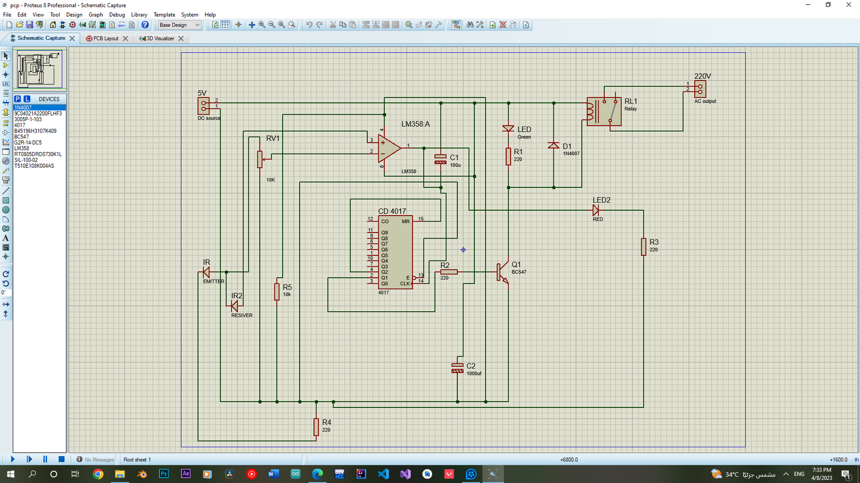

**INTERNAL IC DESIGN: -**

**1-IC CD4017 internal design with explain how it works:**

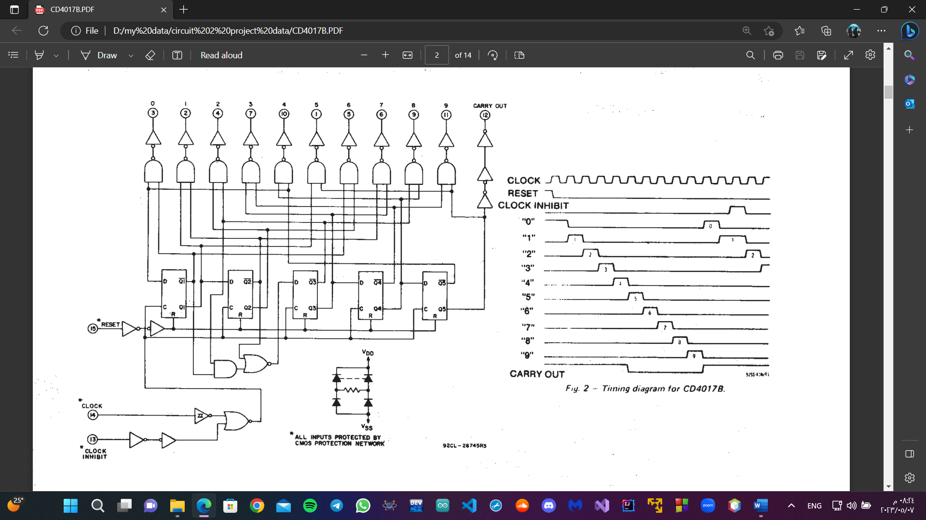

**The CD4017 IC is a *decade counter* that counts to ten. It has 10 outputs that represent the numbers 0 to 9. The counter increases with one for every rising clock pulse. After the counter has reached 9, it starts again from 0 with the next clock pulse.**

**What is a Decade Counter?**

A decade counter counts to 10. You can remember it by thinking of a decade in years, which is *ten* years.

It’s very common that a counter will give you the output in binary form. But the output from the decade counter in the CD4017 is decoded, meaning that it will set one of the output pins (Q0 to Q9) high corresponding to the counter value. Ex: If Q3 is high, the counter value is 3.

The easiest way to create a decade counter is by connecting 10 [D flip-flops](https://www.build-electronic-circuits.com/d-flip-flop/) in series to create a [shift register](https://www.build-electronic-circuits.com/shift-register/). Then you connect the output of the last flip-flop back into the input of the first. And you connect the reset signal so that it sets the first flip-flop to one and the rest to zero on reset.

This is also known as a ring counter.

**2-IC LM358 internal design with explain how it work**

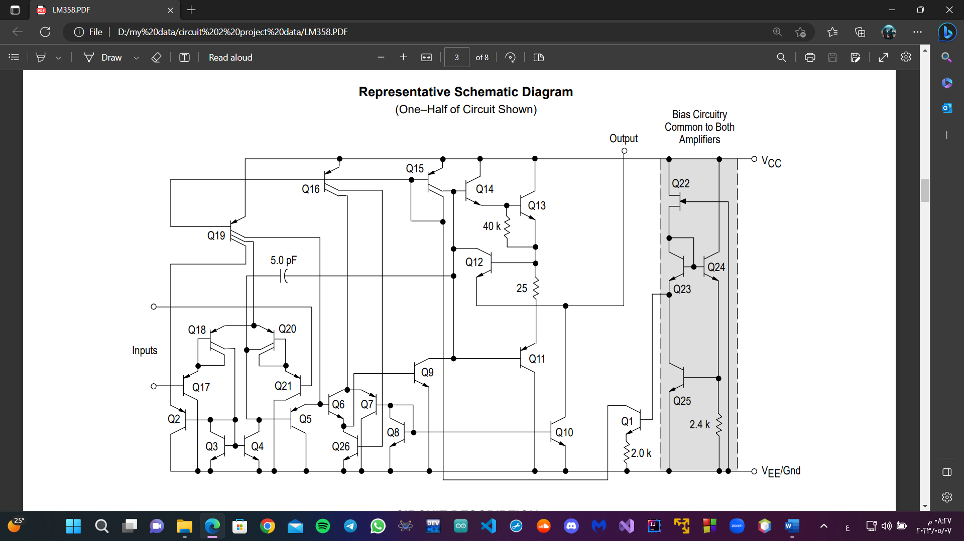

**The LM358 series is made using two internally compensated, two–stage operational amplifiers. The first stage of each consists of differential input devices Q20 and Q18 with input buffer transistors Q21 and Q17 and the differential to single ended converter Q3 and Q4. The first stage performs not only the first stage gain function but also performs the level shifting and transconductance reduction functions. By reducing the transconductance, a smaller compensation capacitor (only 5.0 pF) can be employed, thus saving chip area. The transconductance reduction is accomplished by splitting the collectors of Q20 and Q18. Another feature of this input stage is that the input common mode range can include the negative supply or ground, in single supply operation, without saturating either the input devices or the differential to single–ended converter. The second stage consists of a standard current source load amplifier stage. Each amplifier is biased from an internal–voltage regulator which has a low temperature coefficient thus giving each amplifier good temperature characteristics as well as excellent power supply rejection.**

**PCB LAYOUT: -**

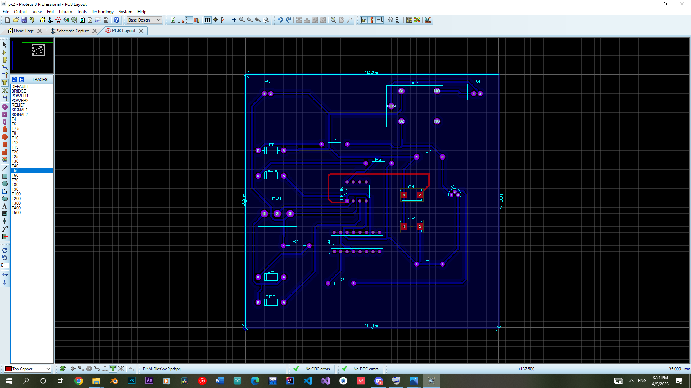

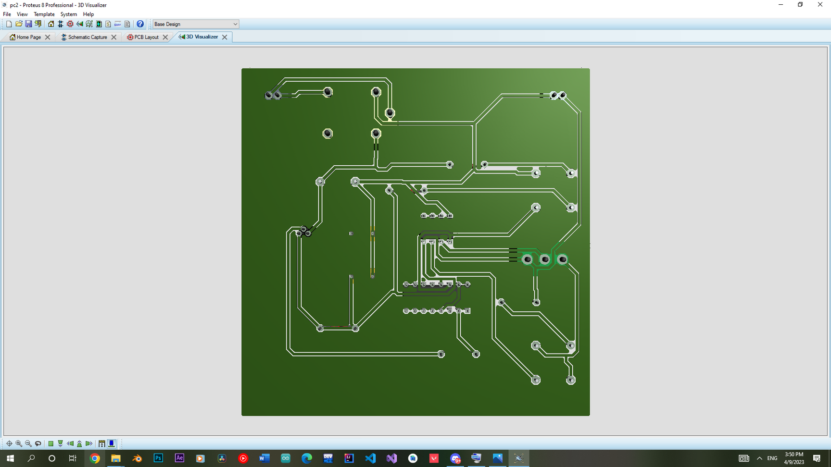

**How the circuit work: -**

**1- THE IR EMITTER LED CONTINUOUSLY EMITS INFRARED. WHEN ANY OBJECT COMES WITHIN THE RANGE, SOME AMOUNT OF INFRARED REFLECTS FROM THE OBJECT’S SURFACE AND THAT REFLECTED INFRARED CAN BE DETECTED BY THE IR RECEIVER LED.**

**2- THE LM358 COMPARES THE VOLTAGE ACROSS THE IR RECEIVER LED WITH THE PREDEFINED VALUE. WHEN ANY MOTION IS DETECTED THE VOLTAGE ACROSS THE IR RECEIVER CROSSES THE PREDEFINED VALUE, SO THE OUTPUT PIN (PIN 1) OF LM358 BECOMES HIGH.**

**3- THE CLOCK PIN (PIN-14) OF CD4017 IC IS CONNECTED TO THE OUTPUT PIN OF LM358. SO, WHEN ANY MOTION IS DETECTED, THE 4017 IC RECEIVES A CLOCK PULSE AND CHANGES THE CURRENT STATE OF PIN-2**

**4- THE PIN-2 OF CD4017 IS CONNECTED WITH THE BASE OF THE BC547 NPN TRANSISTOR, SO WHEN THE PIN-2 BECOMES HIGH THE TRANSISTOR TURNS ON.**

**5- WHEN THE TRANSISTOR TURNS ON, THE CURRENT CAN FLOW THROUGH THE RELAY COIL. SO, THE LOAD CONNECTED WITH THE RELAY ALSO TURNS ON.**

**6- WHEN THE IR LEDS DETECT ANY MOTION THE SECOND TIME, IT SENDS THE NEXT CLOCK PULSE TO CD4017 IC. THEN THE PIN-2 BECOMES LOW.**

**6- WHEN THE IR LEDS DETECT ANY MOTION THE SECOND TIME, IT SENDS THE NEXT CLOCK PULSE TO CD4017 IC. THEN THE PIN-2 BECOMES LOW.**